
LAB TASK OP SYS
OPERATING SYSTEMS

MUHAMMAD ARSLAN NAZIR
F2024332048
23/10/2026

Task 1: Creation of a folder named after name-id:
I used a simple mkdir command followed with my folder name and that created a folder named arslan-f2024332048. You can see the verification using the ls command that lists all the contents of the folder.
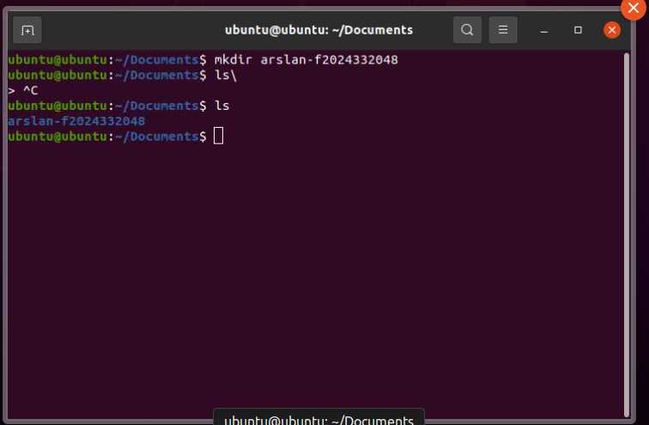

Task 2: Creation of nested folders:
For this task I used mkdir command followed with a -p flag that is used to create nested folders after the -p flag I typed the folder names with their structure and folders were created.
Task 3: List folders recursively
Used ls -R command to list all folders recursively, you can also verify that the folders we created earlier are in the same directory format.
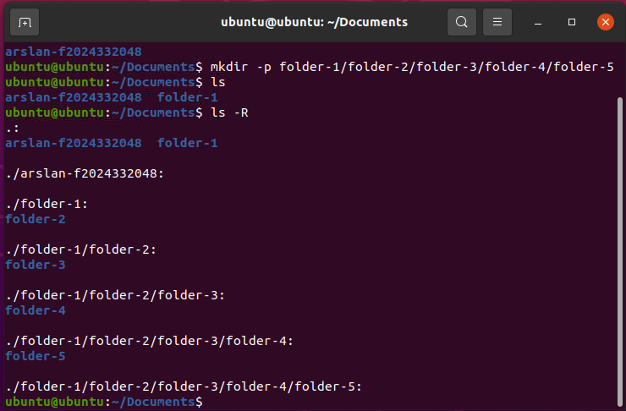

Task 4: Creating an editing a file using nano
I used nano to create a file named larka.txt and I wrote two lines that described me and then I used ctrl+o to save the file and ctrl+x to exit the editing terminal.
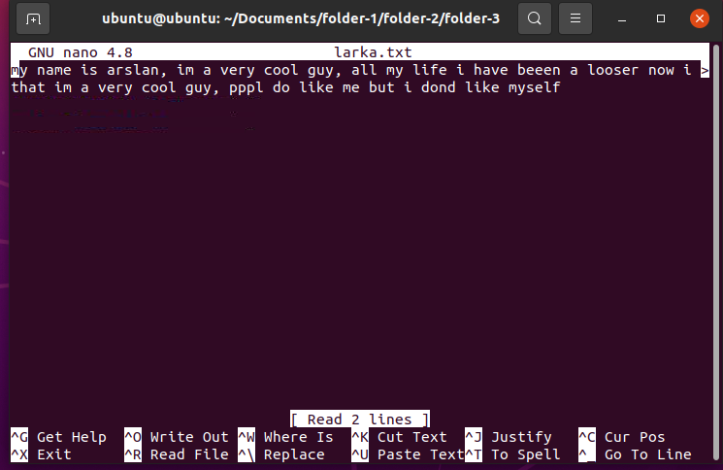

Task 5: showing the contents of file
I simply used cat command followed by the file name to list all the contents of the file.
